Project Book Launch of
Delivering a Successful Project
The Project Manager’s Handbook by Ing. Albert K. Ortsin
1. 📖 INITIATION PHASE
Project Charter: Book Launch Event
Project Title: Launch of Delivering a Successful Project: The Project Manager’s Handbook
Author: Albert K. Ortsin
Event Date: Thursday, 29th May 2025
Event Time: 4:00 PM – 6:00 PM GMT
Venue: GIMPA Executive Conference Centre
Expected Attendance: Initial: 100 guests, Current: 70 guests

1.1. Project Purpose and Objective
The purpose of this project is to successfully organize and execute the official launch of Delivering a Successful Project: The Project Manager’s Handbook.
Objectives include:
- Host a well-coordinated and professional event.
- Generate media attention and professional buzz around the book.
- Promote networking among project management professionals.
- Achieve successful book sales and potential auction during the event.
1.2. Scope no
In Scope:
- Venue booking and logistics coordination.
- Event marketing and invitation dissemination.
- Guest and media coordination.
- Book display, sales, and signing setup.
- Photography, documentation, and press engagement.
Out of Scope:
- Post-launch book distribution beyond the event.
- Long-term media campaigns (unless separately initiated).
1.3. Key Stakeholders
Role | Name
Author, Book Printing, Social Media Marketing, Guest Invitations | Albert K. Ortsin
Documentation, Operations Direction, Coordination | Elliot Yamoah (Coordinator)
Event Host MC, Book Packaging, Auctioning, Fundraising | Robert Dela Mawuenyegah  (EmCee Robby)
IT Support, Audio-visuals, Backdrop/Props, Protocol & Ushering, Event Coordination Team | Michael Oppong & Appointed Members
Registration, Logistics, Coordination, Feedback | GIMPA-GTC Rep, GIMPA Management & Support Staff
Media & Press | Guest Speakers, Special Invitees & representatives
Attendees | PMP students, professionals, alumni, general public

1.4. Deliverables
- Professionally executed launch event.
- Coordinated guest arrival and participation.
- Media coverage and photography archive.
- Book sales and event memorabilia (e.g., signed copies).
- Post-event summary report.

1.5. Constraints & Assumptions
- The event must occur within the designated date/time.
- Budget limitations as specified by the Author/Sponsor.
- Venue availability confirmed at GIMPA.
- All planning and approvals coordinated within PMO operating hours.
1.6. Risks
Risk | Likelihood | Mitigation Strategy
Late arrival of key guests | Medium | Buffer in program start; early confirmation
Technical issues at venue | Medium | Early testing of A/V equipment
Low media turnout | Low | Pre-engagement and personal media invites
Weather-related disruption | Low | Indoor venue, not weather-dependent

1.7. Timeline
- Planning & Coordination: Ongoing until June 25th, 2025
- Pre-Event Setup: June 26th, 2025 (12:00 PM – 3:30 PM)
- Event Execution: June 26th, 2025 (4:00 PM – 6:00 PM)
- Post-Event Review & Report: Within 1 week after event

1.8. Budget Overview
A detailed budget will be reviewed and approved during team planning sessions. All expense approvals must follow PMO and sponsor protocols.

1.9. Approval Signatures
By signing this charter, all parties acknowledge their roles, agree to the objectives, and commit to supporting the successful execution of the project.
Name & Role | Signature | Date
Ing. Albert K. Ortsin  (Author/Sponsor)  +233 20 887 6407 | _______________________ | _________________
Elliot Yamoah  (Coordinator)  +233 24 288 4262 | _______________________ | _________________
Kafui Dey  (MC) | _______________________ | _________________
Michael Oppong  (Event Team)  +233 54 389 8144 | _______________________ | _________________
Mrs. Regina Nyantekyiwa  (GIMPA-GTC Rep)  +233 24 601 5233 | _______________________ | _________________

Annex A: PMO Governance Overview – IAPD National
IAPD National (Independent Assignments & Projects Development) is the administrative arm of Koware Enterprise, overseeing internal and external projects. It also houses the Project Management Office (PMO), ensuring structured coordination, execution, and accountability across all assignments.
🎯 PMO Purpose & Functions
The PMO under IAPD National serves a central coordinating and governance role across all Koware-sponsored projects. It ensures consistency, compliance, and efficiency throughout the project lifecycle by supporting planning, stakeholder alignment, and quality assurance. Key responsibilities include:
- Lifecycle oversight from initiation to closure
- Monitoring of schedule, cost, quality, and risk
- Standardized tools, templates, and reporting
- Coordination among sponsors, vendors, and teams
- Milestone tracking, gate reviews, and documentation
🕒 Operating Hours & Availability
The PMO operates Monday to Friday, 8:30am – 4:30pm (GMT), and is closed on weekends and public holidays. All project-related activities must be scheduled within these hours. After-hours or emergency requests are subject to availability and attract additional fees to cover staff overtime and expedited service, with approval through the Corporate Manager.
👤 PMO Oversight & Contact
Primary Contact: Elliot Yamoah
Corporate Manager, IAPD National
📧 [elliot.yamoah@st.gimpa.edu.gh] | 📞 [+233-24-288-4262]

2. 📖 PLANNING PHASE

Phase 2.1: Planning
• Deliverable 1.1: Venue Booking
o Work Package 1.1.1: Contact GECC and confirm hall availability (Leticia - 0244762672)
o Work Package 1.1.2: Review and sign venue contract
o Work Package 1.1.3: Pay booking fee (6000 GHS)
• Deliverable 1.2: Catering Arrangements
o Work Package 1.2.1: Finalize catering menu and headcount (GECC Catering @100 GHS/person)
o Work Package 1.2.2: Confirm catering service agreement and payment terms
o Work Package 1.2.3: Communicate final guest list to caterers (2 weeks before event)
• Deliverable 1.3: Book Launch Materials
o Work Package 1.3.1: Print copies of "Delivering a Successful Project" for launch (Target: 300 copies)
o Work Package 1.3.2: Arrange book sales logistics (pricing, payment options, receipts)

Phase 2.2: Publicity
• Deliverable 2.1: Invitations and Promotion
o Work Package 2.1.1: Design event flyer, poster, and social media graphics
o Work Package 2.1.2: Print physical invitations and promotional materials
o Work Package 2.1.3: Distribute invitations via email, WhatsApp, direct calls, and social media

INVITATION CARD:

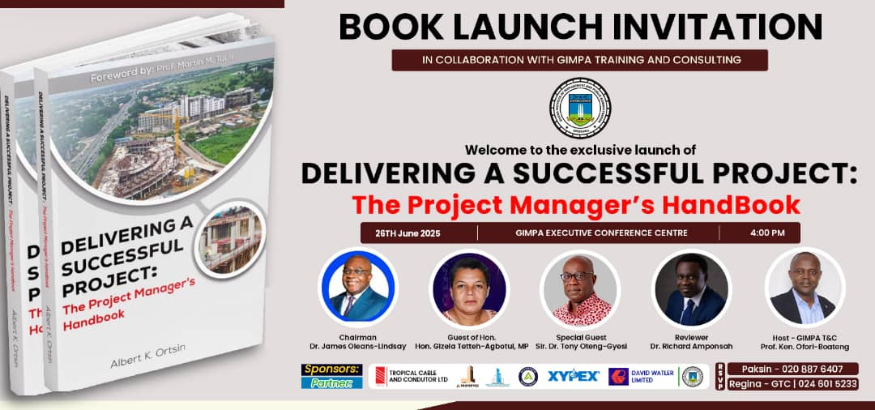

High Table Dignitaries:
- 🎯 Chairman - Accepted Invitation.
- 🎯 Guest of Hon.MP. - Accepted Invitation.
- 🎯 Special Guest. - Accepted Invitation.
- 🎯 Book Reviewer - Accepted Invitation.
- 🎯 MC. - Ready on Standby.
- 🎯 Host - Available

Invitations to Institutions as at 20/6/25:
- 📌 Wks/Housing & Water Resourc. Ministry.
- 📌 Accra Technical. University.
- 📌 Cape Coast Tech. University
- 📌 University of Prof. Studies.(UPSA)
- 📌 Gh. Telecom University.
- 📌 Gh Police - Project/Estate Dept.
- 📌 Gh. Immigration Service.
- 📌 Gh Army - Project/Engineering Dept.
- 📌 48 Engineer Regiment.
- 📌 Gh Institute of Architects.
- 📌 Ghana Institute of Engineering.
- 📌 Institution of Engineering & Technology - Gh.
- 📌 Department of Feeder Roads.
- 📌 Department of Urban Roads.
- 📌 African Univ. College of Communication.
- 📌 Local Government Service.
- 📌 Accra Metropolitan Assembly.
- 📌 ABSA-Bank. Project Dept.
- 📌 Ecobank. - Enterprise Dept.
- 📌 Bank of Ghana - Estate Dept.
- 📌 StandChat Bank.
- 📌 GA East Assembly.
- 📌 GRA - Customs Division

Invitations sent to Individuals as at 23/6/25:
- Emmanuel Samini
- Emmanuel Samini
- Emmanuel Samini
- Obed Parry
- Solomon Mascott
- Action Chapel, Mrs Ohemeng
- GIMPA OIPD, Dr. Quagrainne
- GIMPA, Dr Stephen Odonkor
- Adenta AMA

More Invitation details:
Cape Coast Tech. University Professor Emmanuel Bamfo-Agyei* Dean, School of Graduate Studies
University of Prof. Studies.(UPSA), Dr. Samuel Koomson
Knust Dr. Dickinson Agyapong-Bempa, strategic execution & project management consultant*
Ing Tony Essilfie, former chief director ministry of roads and highways
Architect Tony Asare President of Ghana institute of Architects
Dr. Ing. Ayiboi
Ing Alex Arye, former president of Ghana institute of engineers
Mr kweku Sekyi-Aidoo Absa bank, head of corporate real estate solutions
Mr Steven Amo bank of Ghana estate and project management
Lieutenant Colonel Amponsah director of Engineering services, Ghana army
Mr Eden Tekpor Gbeckor-kove, Physical Planning, AMA
Ing. Lartey, AmA
Meeting at Ministries
Hon. Gizela Tetteh-Agbotul, MP
Deputy Minister
Architect Chris Abbey

Introductions
Formal letter - background of event

Professor Kenneth
Dr Obodai from Wenchi

Tekton Architects
Magnus kwashie
Vice President/Hon secretary
June 20th - 27th tentative
GIA President Articles

Officer Emmanuel Kyereme
Estate Department
Ghana Immigration
0241527958

Burma Camp DES
Col Wiafie
Engineering
Burma Camp

Valley View University
Prof Garikuma/Gagakuma
0549421696
W0502282269
June 12 birthday
Notes - Manuscript stage
Draft Stage
Communication plan
Incidents and accidents
Executive Summary of the Project Management Plan
Change Management, Change Control Process, Ch13
Marketing scope

Ups
head of department business administration
Dr Ummu
0244990755

GTV
Mr Kafui
4k on the day

48 Burma Camp
Leftenant Amponsah

Front Seats
Ayem, Ecobank

BoG
Vera
0244640377

Mr Assan
Head of Estates
Ghana Customs GRA2
0244268770

AMA
Mr Eden Tekpor Gbeckor-kove
Physical Planning

Ing. Lartey
0546405013

DISTRIBUTED INVITATION LETTERS:
DRAFT
Hon. Gizela Tetteh-Agbotul, MP
The Deputy Minister
Works, Housing and Water Resource.
Date: 03/06/2025
Dear Hon. Gizela Tetteh-Agbotul,
Re: Invitation to Book Launch as Guest of Honour.
It is with great pleasure that I write to formally invite you to serve as Guest of Honour at the launch of "Delivering a Successful Project: The Project Manager’s Handbook", authored by Engr. Albert K. Ortsin. The event is scheduled for Thursday, 26th June 2025, from 4:00pm to 6:00pm, at the GIMPA Executive Conference Centre (GECC), Accra.
This timely publication provides a comprehensive guide to the principles and practices of successful project delivery and is poised to become a vital resource for both aspiring and practicing project managers across sectors.
Your extensive contributions to national development, and your leadership in infrastructure, governance, and public service, align strongly with the core themes of this book. Your presence would be a great honour and inspiration to our audience of professionals, students, and policymakers. We would be deeply honoured by your acceptance of this invitation.
Please find attached:
1. A brief programme outline.
2. The book summary.
3. A drafted invitation card.
Our team would be happy to coordinate with your office for any necessary arrangements.
Thank you for considering our invitation, and we look forward to the opportunity to host you.
Warm regards,
Prof. Kenneth Ofori Boateng
Director, GTC.
Programme Outline
Activity | Responsibility
Guest Arrival & Registration | Ushers & Registration  Team
Guests Seated / Background Music | Ushers & Protocol  Team
Opening Prayer / Dedication | Pastor
Welcome & Purpose of Gathering | MC
Introduction of Chairman & Acceptance Remarks | MC
Introduction of High Table Personalities: Guest of  Honour (MP), Special Guest / Keynote Speaker,  Reviewer – Prof. Gagakum, Sponsors / Partners  Mentions | MC
Welcome Address from Host Institution | Prof. Ofori-Boating  (Director, GTC)
Book Review – Summary | Prof. Gagakum
Live Reading: Selected Teaser Excerpts | Dr. Ntow / Leticia  (Lady Arc)
Special Guest / Keynote Address | Sir Dr. Tony Oteng  Gyesi
Address by Guest of Honour (MP) | Hon. MP
Introduction of the Author & Background to the  Book: "The Journey Behind Delivering a Successful  Project" | MC
Book Unveiling Ceremony & Fanfare | Author, Host Team,  Protocol, MC
Book Auction – Special Packages | MC / Leticia (Lady  Arc)
Appreciation & Recognition of Sponsors / Partners | MC
Closing Remarks by Chairman | Chairman
Vote of Thanks / Closing prayer | Leticia (Lady Arc)
Book Signing & Refreshments Served | Author & Catering  Team
Group Photographs: Special Guests, Host / GTC  Team, Dignitaries, Protocol / Ushers, GIMPA-PMP  Alumni – Class by Class, All Attendees | Photographer / Leticia  (Lady Arc.) / Protocol  Team

The Book.

Summary.
A practice-oriented Handbook that offers practical approach and application of the project management theory; focusing on key elements, activities, processes, and procedures. It provides information on integrated traditional and contemporary project management knowledge, and also offers exposure to good principles and best practices.

The book also envisages giving guidance to project management professionals, practitioners, students of project management, and specialised functionaries for the successful implementation of their project delivery assignments.

Your career field could possibly differ; however, the application principals are generally the same across industries; the management tools, techniques, and procedures adopted must be tailored to match the magnitude, characteristics, and duration of the particular project - A project is a project.

A modest contribution to the knowledge base of project management professional practice.
DRAFT
The Director,
WASHealth Ghana.
Accra.

Date: 9th June, 2025.

Dear Dr. Stephen Ntow,

Re: Letter of Confirmation - Invitation and acceptance as the Live Excerpts Reader at the Book Launch Event – "Delivering A Successful Project: The Project Manager’s Handbook"

Please, I write as a follow-up to your private discussions with the book author on Sunday, 4/5/25 (Ntow/Ortsin) at St. Thomas More, Achimota and your subsequent acceptance of this special role as Live Excerpt Reader for the occasion of our Book Launch Event.

GIMPA Training and Consulting, in collaboration with the book author, Albert K. Ortsin in recognition of your insights and contributions to health systems strengthening and project-related programmes aligns perfectly with the purpose of the occasion, and your participation will add immense value to the event. We believe your selected readings will inspire attendees, particularly aspiring and practicing project managers, in delivering impactful projects.

Date:- Thursday, 26th June 2025.
Venue:- GIMPA Executive Conference Center.
Time:- 4:00 - 6:00 pm.

We look forward to celebrate this special occasion with you.

Kindly find attached for your attention, a copy of:

The Progamme Outline.
The Book Summary.

Best regards,

Yours Sincerely,
---------------------------
Kenneth Ofori-Boateng.(PhD.)
Professor, Director, GIMPA Training & Consulting Directorate.

Cc.
Engr. Albert K. Ortsin.
Book Author.

DRAFT
The Chairman,
Tropical Cable and Conductor Ltd.
Accra.

Date: 9th June, 2025

Dear Sir, Dr. Tony Oteng-Gyasi,

Re: Letter of Confirmation.

Invitation and acceptance as Special Guest/Keynote Speaker for the Book launch Event - "Delivering A Successful Project: The Project Manager’s Handbook."
--------------------------------------------
Please, I write as a follow-up to your private discussions with the Book Author on Wednesday, 16/4/25 (Oteng-Gyasi/Ortsin) in the private conference room of your airport office and your subsequent acceptance for the Special Guest role for the occasion of our Book Launch Event,
GIMPA Training and Consulting, in collaboration with the book author, Albert Kwesi Ortsin therefore wishes to formally express our profound gratitude and to also confirm your acceptance of our special invitation to our Book Launch Event at Gimpa.

Date: Thursday 26th June 2025

Venue: GIMPA Executive Conference Centre.

Time: 4:00–6:00pm

Again, we are thankful to you for the continued interest and support to the construction industry, general project-related programmes and being available for this special occasion of our Book Launch.

Kindly find attached for your attention, a copy of:

The Programme Outline.
The Book Summary.
Invitation Card.

Thank you,

Yours Sincerely,
........................
Kenneth Ofori-Boateng.(PhD.)
Professor, Director, GIMPA Training & Consulting Directorate.

Cc.
Engr. Albert Kwesi Ortsin.
Book Author

Programme Outline

Activity | Responsibility
Guest Arrival & Registration | Ushers & Registration  Team
Guests Seated / Background Music | Ushers & Protocol  Team
Opening Prayer / Dedication | Pastor
Welcome & Purpose of Gathering | MC
Introduction of Chairman & Acceptance Remarks | MC
Introduction of High Table Personalities: Guest of  Honour (MP), Special Guest / Keynote Speaker,  Reviewer – Prof. Gagakum, Sponsors / Partners  Mentions | MC
Welcome Address from Host Institution | Prof. Ofori-Boating  (Director, GTC)
Book Review – Summary | Prof. Gagakum
Live Reading: Selected Teaser Excerpts | Dr. Ntow / Leticia  (Lady Arc)
Special Guest / Keynote Address | Sir Dr. Tony Oteng  Gyesi
Address by Guest of Honour (MP) | Hon. MP
Introduction of the Author & Background to the  Book: "The Journey Behind Delivering a Successful  Project" | MC
Book Unveiling Ceremony & Fanfare | Author, Host Team,  Protocol, MC
Book Auction – Special Packages | MC / Leticia (Lady  Arc)
Appreciation & Recognition of Sponsors / Partners | MC
Closing Remarks by Chairman | Chairman
Vote of Thanks / Closing prayer | Leticia (Lady Arc)
Book Signing & Refreshments Served | Author & Catering  Team
Group Photographs: Special Guests, Host / GTC  Team, Dignitaries, Protocol / Ushers, GIMPA-PMP  Alumni – Class by Class, All Attendees | Photographer / Leticia  (Lady Arc.) / Protocol  Team

The Book

Summary

A practice-oriented Handbook that offers practical approach and application of the project management theory; focusing on key elements, activities, processes, and procedures. It provides information on integrated traditional and contemporary project management knowledge, and also offers exposure to good principles and best practices.

The book also envisages giving guidance to project management professionals, practitioners, students of project management, and specialised functionaries for the successful implementation of their project delivery assignments.

Your career field could possibly differ; however, the application principals are generally the same across industries; the management tools, techniques, and procedures adopted must be tailored to match the magnitude, characteristics, and duration of the particular project - A project is a project.

A modest contribution to the knowledge base of project management professional practice.

DRAFT
The Managing Consultant.
Management Training & Consultancy,
Oyarifa, Accra.

Date : 9th June, 2025.

Dear Prof. Wisdom A. Gagakuma,

Re: Invitation to Book Launch as Book Reviewer – Delivering A Successful Project: The Project Manager’s Handbook

I am writing to extend our heartfelt appreciation for your invaluable scholarly input, encouragement, and unwavering support during the review of the manuscript of the book, "Delivering A Successful Project: The Project Manager’s Handbook".

Your expertise and thoughtful contributions played a crucial role in shaping the content and quality of the work from its early stages. Your insightful feedback not only enhanced the depth and clarity of the manuscript but also inspired the author throughout the development process.

GIMPA Training and Consulting, in collaboration with the book author, Albert Kwesi Ortsin in recognition of your contribution and in appreciation of your dedication to advancing project management knowledge, training, and scholarship, are honored to formally extend an invitation to you for the Book Launch Event as the official reviewer of the book.

Date: Thursday 26th June 2025
Venue: GIMPA Executive Conference Centre.
Time: 4:00 - 6:00pm

We would be grateful for your acceptance of the invitation for this special occasion of our Book Launch

Also, it is worthy of note that the author has included your name in the acknowledgments as the principal reviewer.

Thank you once again for your outstanding support and interest to see the book published.

Kindly find attached for your attention, a copy of:

The Progammme Outline.
The Book Summary.
Draft Invitation card.

Thank you.

Yours Sincerely,
-------------------------
Kenneth Ofori-Boateng. (PhD.)
Professor, Director, GIMPA Training and Consulting Directorate.

Cc.
Engr. Albert Kwesi Ortsin.
Book Author

Programme Outline
Activity | Responsibility
Guest Arrival & Registration | Ushers & Registration  Team
Guests Seated / Background Music | Ushers & Protocol  Team
Opening Prayer / Dedication | Pastor
Welcome & Purpose of Gathering | MC
Introduction of Chairman & Acceptance Remarks | MC
Introduction of High Table Personalities: Guest of  Honour (MP), Special Guest / Keynote Speaker,  Reviewer – Prof. Gagakum, Sponsors / Partners  Mentions | MC
Welcome Address from Host Institution | Prof. Ofori-Boating  (Director, GTC)
Book Review – Summary | Prof. Gagakum
Live Reading: Selected Teaser Excerpts | Dr. Ntow / Leticia  (Lady Arc)
Special Guest / Keynote Address | Sir Dr. Tony Oteng  Gyesi
Address by Guest of Honour (MP) | Hon. MP
Introduction of the Author & Background to the  Book: "The Journey Behind Delivering a Successful  Project" | MC
Book Unveiling Ceremony & Fanfare | Author, Host Team,  Protocol, MC
Book Auction – Special Packages | MC / Leticia (Lady  Arc)
Appreciation & Recognition of Sponsors / Partners | MC
Closing Remarks by Chairman | Chairman
Vote of Thanks / Closing prayer | Leticia (Lady Arc)
Book Signing & Refreshments Served | Author & Catering  Team
Group Photographs: Special Guests, Host / GTC  Team, Dignitaries, Protocol / Ushers, GIMPA-PMP  Alumni – Class by Class, All Attendees | Photographer / Leticia  (Lady Arc.) / Protocol  Team

The Book

Summary

A practice-oriented Handbook that offers practical approach and application of the project management theory; focusing on key elements, activities, processes, and procedures. It provides information on integrated traditional and contemporary project management knowledge, and also offers exposure to good principles and best practices.

The book also envisages giving guidance to project management professionals, practitioners, students of project management, and specialised functionaries for the successful implementation of their project delivery assignments.

Your career field could possibly differ; however, the application principals are generally the same across industries; the management tools, techniques, and procedures adopted must be tailored to match the magnitude, characteristics, and duration of the particular project - A project is a project.

A modest contribution to the knowledge base of project management professional practice.

o Work Package 2.1.4: Create event page on Facebook and LinkedIn
• Deliverable 2.2: Media Coordination
o Work Package 2.2.1: Identify and engage media partners (radio stations, blogs, online platforms)
o Work Package 2.2.2: Draft and send press releases to selected media houses
o Work Package 2.2.3: Schedule interviews and appearances for author in week leading up to launch
o Work Package 2.2.4: Organize live streaming plan (Facebook Live / Instagram Live if applicable)

Phase 2.3: Logistics
• Deliverable 3.1: Decorations and Setup
o Work Package 3.1.1: Design and produce event backdrop, banners, and podium branding
o Work Package 3.1.2: Procure event décor (flowers, centrepieces, table covers, chairs arrangement)
o Work Package 3.1.3: Hire decorators for setup and teardown
• Deliverable 3.2: Audio-Visual and Photography
o Work Package 3.2.1: Rent and test PA system, microphones, projector, and screen
o Work Package 3.2.2: Hire professional photographer and videographer for full event coverage
o Work Package 3.2.3: Coordinate live projection of activities (stage screen, if available)
o Work Package 3.2.4: Set up lighting for stage and audience areas
• Deliverable 3.3: Guest Comfort and Accessibility
o Work Package 3.3.1: Rent extra fans or cooling equipment if needed
o Work Package 3.3.2: Arrange parking guidance and signage
o Work Package 3.3.3: Set up registration table with name tags and welcome kits

Phase 2.4: Event Execution
• Deliverable 4.1: Guest Management
o Work Package 4.1.1: Set up guest registration desk and sign-in sheets
o Work Package 4.1.2: Assign protocol/ushers and coordinators for welcoming and seating guests
Volunteers
- Celestine: +224629896534
- Veronica: 055-582-6843
- Regina: 024-601-5233
- Joyce: 024-443-1280
- Ing. Hans: 024-092-5954
- Jessica: 055-658-8507
- Richard: 024-4-36-6801
- o Work Package 4.1.3: Prepare VIP guest area and protocol guidelines
• Deliverable 4.2: Program Coordination
o Work Package 4.2.1: Finalize and print program agenda (with timing)
o Work Package 4.2.2: Confirm Master of Ceremony (MC) and speakers’ availability and readiness
o Work Package 4.2.3: Organize launch activities (book unveiling, signing ceremony)
o Work Package 4.2.4: Coordinate transition between program segments (ushers cueing speakers)
• Deliverable 4.3: Emergency Preparedness
o Work Package 4.3.1: Confirm onsite first aid kit availability
o Work Package 4.3.2: Assign point persons for security and emergencies

Phase 2.5: Post-Event Activities
• Deliverable 5.1: Follow-up Communication
o Work Package 5.1.1: Send thank-you emails/messages to guests, sponsors, and partners
o Work Package 5.1.2: Share official event photos and highlight videos online
o Work Package 5.1.3: Publish post-event press release and media coverage recap
• Deliverable 5.2: Financial Reconciliation
o Work Package 5.2.1: Collect and verify final invoices from vendors and service providers
o Work Package 5.2.2: Make final payments and close out all financial obligations
o Work Package 5.2.3: Prepare a detailed financial report for stakeholders
• Deliverable 5.3: Event Evaluation and Lessons Learned
o Work Package 5.3.1: Conduct internal project review and feedback session
o Work Package 5.3.2: Document lessons learned and best practices for future events

3. 📖 EXECUTION PHASE
✍️ Additional Notes:
- Background music (soft instrumental) should play during guest seating and transitions.
- Photography and video recording should occur throughout, especially during the unveiling and book signing.
- Live streaming (if planned) should start precisely at 4:00 PM.
- VIP Guests and Dignitaries should be seated in the first two rows.
- A guestbook should be available at the registration desk for attendees to sign.
- Small tokens of appreciation (e.g., branded pens, bookmarks) can be distributed after book signing.

Programme Outline
Time | Activity | Responsibility
3:30 – 4:00 PM | Guest Arrival & Registration | Ushers & Registration Team
4:00 – 4:10 PM | Guests Seated / Background Music | Ushers & Protocol Team
4:10 – 4:13 PM | Opening Prayer / Dedication | Rev. Fr. Patrick Agbeko
4:13 – 4:15 PM | Welcome & Purpose of Gathering | MC
4:15 – 4:18 PM | Introduction of Chairman & Acceptance Remarks | MC
4:18 – 4:22 PM | Introduction of High Table Personalities: Guest of Honour (MP), Special Guest / Keynote Speaker, Reviewer – Prof. Gagakum, Sponsors / Partners Mentions | MC
4:22 – 4:25 PM | Welcome Address from Host Institution | Prof. Ofori-Boating (Director, GTC)
4:25 – 4:30 PM | Book Review – Summary | Prof. Gagakum
4:30 – 4:35 PM | Live Reading: Selected Teaser Excerpts | Dr. Ntow/Arch. Leticia
4:35 – 4:45 PM | Special Guest | Sir Dr. Tony Oteng Gyesi
4:45 – 4:50 PM | Address by Guest of Honour (MP) | Hon. Gizella Tetteh-Agbotui, MP.
4:50 – 5:10 PM | Introduction of the Author & Background to the Book: "The Journey Behind Delivering a Successful Project" | MC
5:10 – 5:20 PM | Book Unveiling Ceremony & Fanfare | Author, Host Team, Protocol, MC
5:20 – 5:30 PM | Book Auction – Special Packages | MC, Arch. Leticia Araba
5:30 – 5:35 PM | Appreciation & Recognition of Sponsors / Partners | MC
5:35 – 5:40 PM | Closing Remarks by Chairman | Chairman
5:40 – 5:45 PM | Vote of Thanks | Arch. Leticia Araba
5:45 – 6:00 PM | Book Signing & Refreshments Served | Author & Catering Team
6:00 PM onwards | Group Photographs: Special Guests, Host / GTC Team, Dignitaries, Protocol / Ushers, GIMPA-PMP Alumni – Class by Class, All Attendees | Photographer/Arch. Leticia Araba/Protocol Team

4. Monitoring and Control Phase
- Timekeeper ensures activities stay within allotted slots.
- Floaters ("runners") ready for urgent tasks.
- Sound and visuals monitored live throughout.
- Guest registration and feedback collected.
- Team WhatsApp group active for real-time updates.

5. Closing Phase
- Vote of thanks by MC.
- Closing prayer.
- Formal group and individual photographs.
- Quick debrief with the internal team at 6:30 PM.
- Gather feedback from special guests and key attendees.
- Pack down and ensure all rented materials are returned.
- Post-event:
  - Thank-you emails/messages to special guests, sponsors.

Below is a draft of the post Book Launch thank you message via electronic media.
Please peruse and leave your comments and suggestions.
Thank you.
Michael Oppong
(Event Team)

Email

Dear esteemed colleagues and supporters,

We are delighted to express our profound gratitude for your participation and contributions to the successful launch of our book. Your presence and words of commendation have significantly enriched this milestone, and we are honored to have shared this moment with you.

Please accept our sincerest appreciation for your support and enthusiasm. We hope that our book will make a meaningful contribution to the field and inspire further discussion and exploration.

With deepest gratitude,

Albert Kwesi Ortsin
Author (Delivering a Successful Project)

SMS/WhatsApp

To our distinguished guests and supporters,

We wish to convey our deepest appreciation for your attendance and contributions to the book launch. Your involvement has been instrumental in the success of this event, and we are grateful for your continued support.

Sincerely,

Albert Kwesi Ortsin
Author (Delivering a Successful Project)

Social Media (Facebook, Instagram etc)
Book launch success! Huge thanks to everyone who joined us, supported us, and made this dream a reality. We're honored to share this journey with you!
#booklaunch
#gratitude

  - APPRECIATION TO THE HOST, THE DIRECTOR OF THE GIMPA TRAINING AND CONSULTANCY

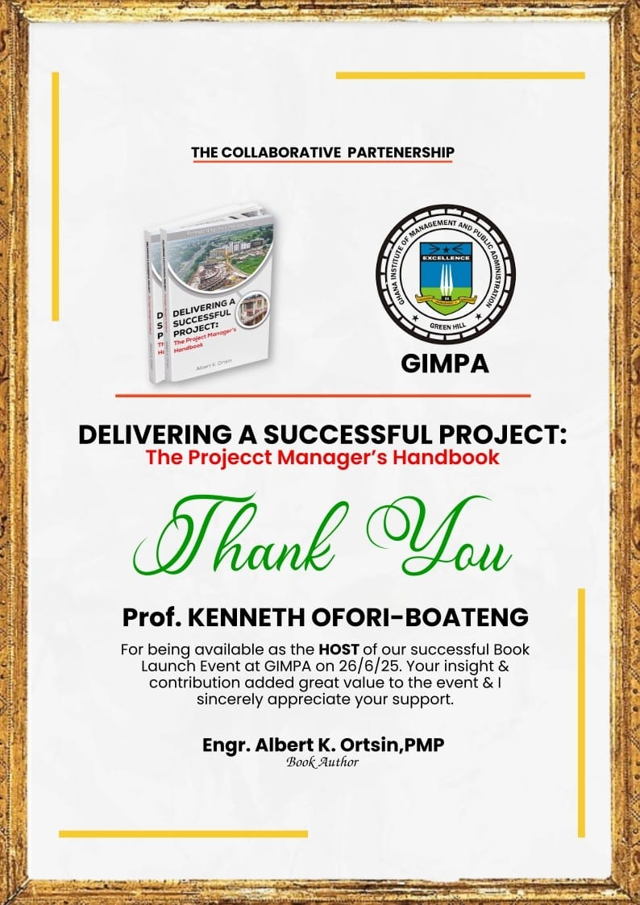

  - Letters of Appreciation sent with official GIMPA Letterhead and signed by the director of the GIMPA Training and Consultancy (GTAC):

30th June, 2025
The Managing Consultant.
Management Training & Consultancy.
Oyibi, Accra.
Dear Prof. Wisdom Gagakuma.
(Assoc. Prof. Ethiopian Civil Service University),
Re: Letter of Appreciation
Appreciation for your acceptance to honor our Book Launch Event invitation - Delivering
A Successful Project: The Project Manager’s Handbook.
GIMPA Training and Consulting (GTC) and our collaborative book author-partner, Albert
K. Ortsin wish to convey our deepest appreciation for accepting the role as Reviewer of
the event. Your critical lens to the book was instrumental in the success of the event, and
we are grateful for your continued support.
Sincerely,
……………………………………………
Prof. Kenneth Ofori-Boateng (Ph.D.)
Director, GIMPA Training & Consulting Directorate
+233244586911, hspgh@yahoo.com/ koboateng@gimpa.edu.gh
Cc.
Engr. Albert K. Ortsin, PMP.
Book Author.

30th June, 2025
Hon. Gizela Tetteh-Agbotui, MP
The Deputy Minister
Works, Housing and Water Resource.
Dear Hon. Gizela Tetteh-Agbotui,
Re: Letter of Appreciation.
Appreciation for your acceptance to honor our Book Launch Event invitation - Delivering
A Successful Project: The Project Manager’s Handbook.
GIMPA Training and Consulting (GTC) and our collaborative book author-partner, wish
to convey our deepest appreciation for accepting the role as Guest of Honor of the event.
Your presence and contribution was instrumental in the success of the event, and we are
grateful for your continued support.
Sincerely,
……………………………………………
Prof. Kenneth Ofori-Boateng (Ph.D.)
Director, GIMPA Training & Consulting Directorate
+233244586911, hspgh@yahoo.com/ koboateng@gimpa.edu.gh
Cc.
Engr. Albert K. Ortsin, PMP.
Book Author.

30th June, 2025
The Chairman,
Tropical Cable and Conductor Ltd.
Accra.
Dear Sir, Dr. Tony Oteng-Gyasi,
Re: Letter of Appreciation.
Appreciation for your acceptance to honor our Book Launch Event invitation - Delivering
A Successful Project: The Project Manager’s Handbook.
GIMPA Training and Consulting (GTC) and our collaborative book author-partner, Albert
K. Ortsin wish to convey our deepest appreciation for accepting the role as Special Guest
of the event. Your presence and contribution was instrumental in the success of the event,
and we are grateful for your continued support.
Sincerely,
……………………………………………
Prof. Kenneth Ofori-Boateng (Ph.D.)
Director, GIMPA Training & Consulting Directorate
+233244586911, hspgh@yahoo.com/ koboateng@gimpa.edu.gh
Cc.
Engr. Albert K. Ortsin, PMP.
Book Author.

30th June, 2025
The Executive Chairman,
JL. Properties.
The Chancellor, Cape Coast Technical University.
Dear Dr. James Orleans-Lindsay,
Re: Letter of Appreciation.
Appreciation for your acceptance to honor our Book Launch Event invitation - Delivering
A Successful Project: The Project Manager’s Handbook.
GIMPA Training and Consulting (GTC) and our collaborative book author-partner, Engr.
Albert Kwesi Ortsin wish to convey our deepest appreciation for accepting the role as
Chairman of the event. Your presence and contribution was instrumental in the success of
the event, and we are grateful for your continued support..
Sincerely,
……………………………………………
Prof. Kenneth Ofori-Boateng (Ph.D.)
Director, GIMPA Training & Consulting Directorate
+233244586911, hspgh@yahoo.com/ koboateng@gimpa.edu.gh
Cc.
Engr. Albert K. Ortsin, PMP.
Book Author.

  - Compilation of photos/videos for promotional use.
  - Lessons learned, documents prepared.
  - THANK YOU TO PROTOCOL
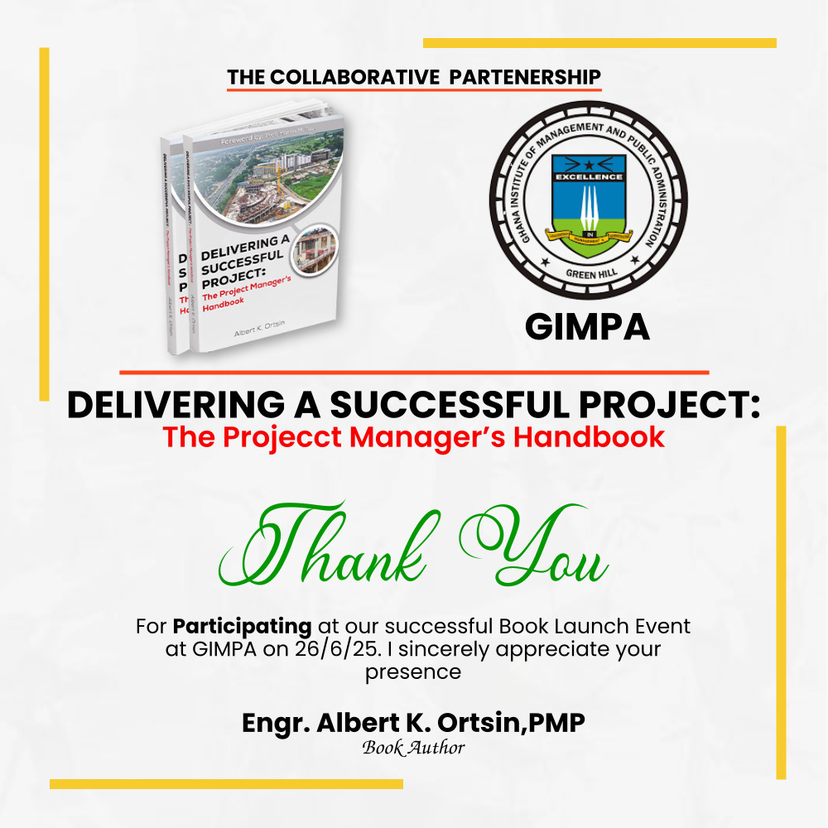

6. Post-Event Review and Lessons Learned
- Team debrief: What went well? What could be improved?
- Financial reconciliation: final cost vs. budget.
INVOICE TO FOLLOW UP ON PLEDGES:

INVOICE Ing. Albert K. Ortsin
Ref: ORTSIN/BL-INV001 Author – “The Project Manager’s Handbook” +233 20 887 6407
Billed To: Date: 27th June 2025
JL Properties
#1 Lindsay Park
Achimota, Accra, Ghana
Attn: Madame Afriyie
Description of Items
Item Description
Quantity
Unit Price
Total (GHS) The Project Manager’s Handbook – Collector’s Edition (Auction Package – Signed Copies)
10
(Auction Offer)
10,000.00 Additional Copies of: The Project Manager’s Handbook – Standard Edition
10
200.00
2,000.00
Total Amount Payable: GHS 12,000.00
Payment Method: Telecel / Mobile Money: 0208876407 Bank Transfer:
- Ecobank Achimota M7 Branch
- Account Name: Albert Kwesi Ortsin
- Account Number: 1441002236335
Thank you for your generous support at the Book Launch held on 26th June 2025 at the GIMPA Executive Conference Centre. Your contribution helps to promote excellence in project delivery and knowledge sharing across industries.
Books will be delivered upon confirmation of payment. Kindly contact us for delivery coordination.
Issued By: Ing. Albert K. Ortsin Author – The Project Manager’s Handbook

- Document best practices for future events.

Notes:
- The programme started at 4.40pm as we waited for invitees to arrive.
- The late arrivals were mainly due to the time people closed from work.
- The military personnel had to leave at the specified time on the original programme outline. The auction had started just before they left so they were able to make a pledge.
- Unveiling of the book went smoothly except for the funfare trumpet sound that the author had prepared for could not play. The MC had brought a pen drive to play his music. When the pendrive was removed the mixing board crashed at the time of the unveiling. A simulation with the MC some days before the event could have resolved this issue.
- The auction did not go as planned. The MC mentioned the price of the packages and when someone put their hand up he closed the auction without waiting for a next bid. The ushers also immediately attended to the person and gave them a book without taking their details. This created a bit of confusion in identifying who had bought a book.
- The programme ended at 6.30pm with a closing prayer. Group photos followed soon afterwards then the guests dispersed.
- The protocol team stayed for about one hour after the program to resolve and identify payments and pending pledges that required follow ups.
- There should have been a sign in sheet for protocol to sign as they arrived and to sign as they left. Those who did not sign in or out or arrived late or left early could face some penalties.
- For future events, simulation should be compulsory a few days before the programme with key persons such as the host, the mc, the media man, the author and the coordinator.
- There should be official procedures for securing volunteers and participants as was done for the dignitaries. Maybe a list where participants and volunteers can sign to confirm acceptance of their participation.

